Annex BB. Neural networks

In NN, standardization of a dataset is a common requirement. It involves rescaling the distribution of values so that the mean of observed values is 0 and the standard deviation is 1. Feature scaling helps not to deviate towards high-range input feature values. The most commonly used feature scaling techniques are absolute Maximum scaling; min-max scaling; normalization; standardization; and robust scaling. It is important to perform feature scaling after splitting the data into training and testing. If scaling is applied before the spilt, the uniqueness of the test data is spoiled.
Neural networks use deep learning methods that aim to discover the underlying patterns of the observed data. The gradient or steepest descent method is used to train a BPNN by adjusting the weights. The purpose of updating the numerical weights is to minimize the loss that quantiﬁes the difference between the expected outcome and the outcome produced by the NN model. Neural networks are inherently designed to tackle multiple targets simultaneously. In a Neural network, the threshold governs the choice to turn a projected probability or score into a class label. The prediction threshold determines what the predicted class is, based on the probabilities that the model outputs. The threshold depends on the tolerance for false positives. For a classifier that outputs a probability, the optimal threshold is selected on the validation set by examining the threshold that yields the best $F1$ score. The F1 score can be interpreted as a harmonic mean of precision(positive predictive value) and recall(sensitivity), where an F1 score reaches its best value at 1 and worst score at 0. The relative contribution of precision and recall to the F1 score are equal. The formula for the F1 score is $F1 = 2 * (precision * recall) / (precision + recall)$. In the multi-class and multi-label case, this is the average of the F1 score of each class with weighting depending on the average parameter $average='weighted'$: metrics for each label is calculated, and their average weighted by support (the number of true instances for each label) is found. This alters ‘macro’/‘micro’ to account for label imbalance.
The training of the NN model is done by repeatedly updating the weights and biases and by carrying out forward and backward propagation having the goal to find the “best” values of the model parameters that minimize the loss function. Neural network uses the Gradient descent method to learn the gradient or direction that the model should take in order to reduce errors (differences between the actual label $y$ and predicted label $y$). The main idea is to compute the value of the loss function at every value of the model parameters and iteratively update the model parameters, to take steps in the local direction of the steepest (negative) slope, i.e., the negative gradient. Consider a cost function $J(θ1)$ and the objective, $\min{J\left(θ1\right). }$When minimizing a cost function according to all $θ1,$start by random initialization at the point $A$. The derivative term is represented by the slope at any point. In this case, it would be a positive slope and, since the learning rate defines how big the steps are during the descent, $α$ is a positive real number. The overall term – $α\frac{d}{dθ1}J\left(θ1\right)$would be negative. This means the value of $θ1$will be decreased in magnitude as shown by the arrows (Figure 1.2.) (Shams, 2022).

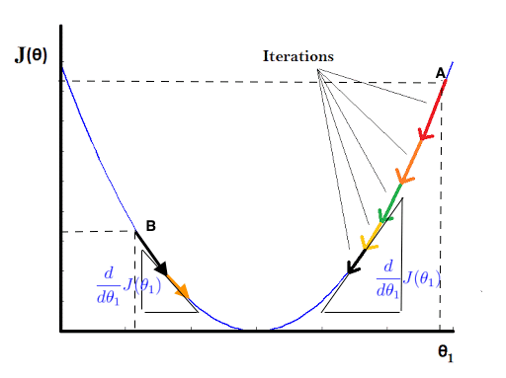
Fig. 1.2. Gradient descent steps (Shams, 2022)
The weight values change according to the principles of gradient descent for each batch of training data that the neural network is trained on. Iteratively repeating the process of running the neural network on a set of training data points, applying a gradient descent protocol, and adjusting the weights of the network, allows the network to activate very specific neural patterns in response to specific inputs thereby allowing it to learn, minimizing its cost function. $α$ will determine the magnitude of the update term. In case of a higher dimensionality problem, the weights should be updated simultaneously. If the update is not simultaneous then the gradient is not computed at the same point because the updated value of one parameter is used in calculating the update of another (Shams, 2022).
A machine learning model always wants low error with maximum accuracy. Generally, the steps to implement Gradient Descent are the following (Mazur 2022):
- randomly initialize values;
- update values: ${weight}^{new}$= ${weight}^{old}$ $- constant$ $\frac{∂J|(θ)}{∂weight},$where $J(θ)$ is loss function (a derivative of error with respect to weight); here $constant$ is a learning rate;
- repeat until $slope =0$.
In general, there are many different variations of the update equation. Each variant is called an optimizer: Gradient Descent (GD), Stochastic Gradient Descent (SGD), Mini Batch Gradient Descent, etc.

